

**STEAKHOUSE and SEAFOOD**

**DINNER HOURS**

Monday - Thursday 5:00 pm - 9:00 pm

Friday and Saturday 4:00 pm - 10:00 pm

Sunday 4:00 pm - 9:00 pm

​**BRUNCH HOURS**

Sunday 10:00 am - 2:00 pm

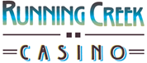

**Running Creek Casino**

**635 East Highway 20 ♣ Upper Lake, California 95485**

**(707) 530-5158**

Please inform your server of any food allergies or dietary restrictions.

Corkage fee $10. Parties of 8 or more will have 15% service charge added.

Due to supply issues beyond our control, we are experiencing shortages in product delivery and accessibility at this time. As a result, we may need to substitute or limit menu item availability.

*Thank you for your understanding.*

**STARTERS**

**Bread and Butter**

Warm bread with whipped butter.  **8**

**Garlic Cheese Bread**

Bread baked with garlic, cheese and caper spread. **10**

**Mushroom and Steak Bites**

Whole mushrooms and tender bites of steak sautéed in garlic butter. **16**

**Caprese Flat Bread**

Roasted garlic basil pesto, served on crispy flat bread topped with mozzarella, tomatoes, fresh basil and balsamic glaze. **13**

**Tempura Prawns**

Four jumbo tempura prawns served with cocktail sauce and lemon. **16**

**Crab & Artichoke Stuffed Mushroom**

A creamy crab and artichoke, Stuffed in 4 large mushroom caps and served with

Garlic Bread. **16**

**Prawns Cocktail**

Five jumbo prawns with shredded lettuce, cocktail sauce and a lemon wedge. **16**

**Calamari**

Rings and tentacles, breaded and deep fried, served with lemon wedge, cocktail and orange wasabi dipping sauce. **16**

**WILD CREEK FAVORITES**

**Wild Creek Burger**

A 1/2 lb seasoned brisket and sirloin patty, cooked to order, with cheese, house burger sauce, lettuce, tomatoes and onions on a seeded brioche bun, served with French fries. **19**

*(Vegan option available add $3.00*

**French Dip**

Thin sliced prime rib, sautéed onions and mushrooms on a toasted roll with a roasted garlic aioli, au jus and French fries. **19**

**Fish & Chips**

Our beer battered Pacific Snapper is served with French fries, tartar sauce and fresh-cut

Lemon wedges. **19**

**SOUP & SALAD**

**House Salad**

Mixed greens, grape tomato, carrots and cucumber with your choice of dressing. **6**

**Caesar Salad**

Chopped romaine lettuce tossed with our house made Caesar dressing, croutons and shredded parmesan cheese. **12**

**Steak Salad**

Mixed greens with strips of tender New York steak, feta cheese, cherry tomatoes, onions and avocado. Choice of Dressing.  **18**

**Iceberg Wedge**

A Wedge of iceberg , avocado, Bacon, bleu cheese crumbles,. Served with house-made Bleu cheese dressing.  **12**

**Soup du Jour**

Ask your server about our soup

of the day. **6**/**9**

**PASTA DISHES**

**Steakhouse Pasta**

Pappardelle, 8 oz New York, mushroom garlic cognac cream sauce, served with garlic bread. **28**

**Stuffed Chicken Florentine**

Stuffed chicken breast with bacon, spinach, linguine and Florentine sauce. Served with garlic bread. **26**

**Pork Stroganoff**

Bits of tender pork, onions and mushrooms in a savory sour cream sauce, served over Peppardelle and served with Garlic bread. **22**

**Seafood Linguine**

Bay scallops, Cajun sausage, mussels, clams, shrimp, tomatoes and green onions in a sherry cream sauce over linguine. Served with garlic bread. **24**

Consuming raw or undercooked meats, poultry, seafood, shellfish, or eggs may increase your risk of foodborne illness.

**SURF & TURF MEALS**

*Menu items below are served with soup or salad.*

**New York Steak**

16 oz New York steak, grilled to order, topped with demi-glaze, served with a baked potato and seasonal vegetables. **38**

**Ribeye Steak**

Ribeye steak, grilled to order, topped with mushroom peppercorn sauce, served with a baked potato and seasonal vegetables. 52

**Bacon Wrapped Filet**

Bacon Wrapped Filet served with garlic mashed potatoes, asparagus and blue cheese bacon chive compound butter. **42**

**Grilled Salmon**

Salmon filet, topped with Hot honey herb compound butter, served with wild rice pilaf, asparagus and fresh cut lemon. **32**

**Tournedos Of Beef**

3 small filet tenderloin steaks grilled to order, topped with Bearnaise sauce, baked potato seasonal vegetables. **38**

**Catch of the Week Market Price**

A new delicious fish special every week!

*Please ask your server for details.*

**ON THE SIDE**

Seasonal Vegetables 7

Baked Potato 7

Garlic Mashed Potatoes 7

Rice Pilaf 7

Asparagus 7

French Fries 7

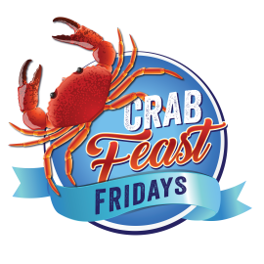Garlic Bread 7

All items are subject to season and availability. Management reserves all rights

**BEVERAGES**

Includes refills unless otherwise indicated.

Pepsi Cola / Diet Pepsi 2

Wild Cherry Pepsi 2

Root Beer 2

Dr. Pepper 2

Mountain Dew 2

Lemonade 2

Iced Tea 2

Sweet Tea/Raspberry Iced Tea 2

Hot Coffee 2

Hot Tea $2ea.

Red Bull ® $3ea.

Rock Star ® $3ea.

Espresso/Cappuccino $3ea.

Vanilla Cappuccino $3ea.

Latté/Mocha $3ea.

**Join us for Breakfast**

**Every Sunday**

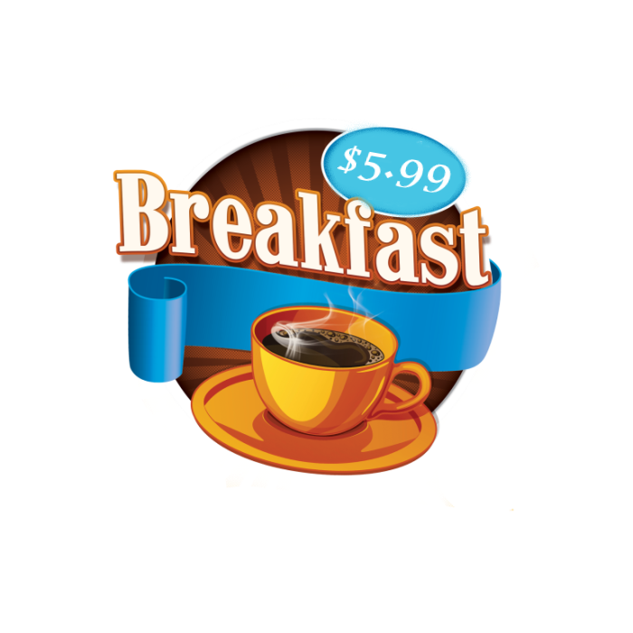

$2 Mimosas & $3 Bloody Mary

10:00 am-2:00 pm

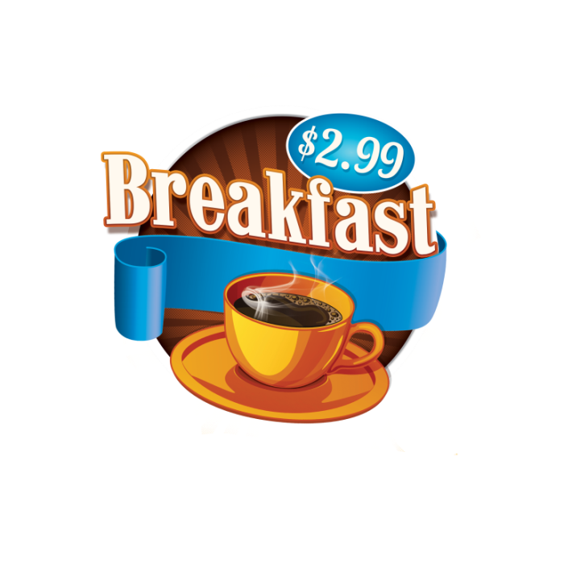



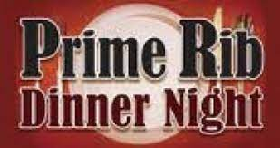

**Saturday**



**Specialty Cocktails**

**White Linen $12 Empress Reviver $14**

Gin, Elderflower liqueur, muddled Empress 1908, Cointreau, Lillet Blanc,

Cucumber, fresh lime juice. Lemon, Absinthe

**The Borrowed Time $11 Tequila Passion $11**

Bulleit Bourbon, Dubonnet, Tequila, Lime, Passion Fruit liqueur,

Angostura bitters, Orange bitters Orange bitters, Orange liqueur

**Alexander $10 The Whiskey Rebellion $10**

Cognac, Crème de Cacao, Bulleit Bourbon, Pimm’s #1,

Cream, Nutmeg Lemon simple syrup

**Adonis $12 P.S. Martini $12**

Vodka, Elderflower liqueur, Vanilla Vodka, Passion Fruit liqueur,

Lemon Dragon fruit simple syrup. Lime simple syrup. (Served with a shot of

sparkling wine).



**Bottled Beer**

**Bud Light $4**

**Budweiser $4**

**Coors $4**

**Coors Light $4**

**Michelob Ultra $4**

**Miller Genuine Draft $4**

**Smirnoff Ice $4**

**Twisted Tea $4**

**White Claw $4**

**Stella Artois $5**

**Angry Orchard $5**

**Blue Moon $5**

**Great White $5**

**Racer 5 $5**

**Sierra Nevada $5**

**Corona $5**

**Heineken $5**

**Modelo $5**

**Schoeferhofer $5**

**Pacifico $5**

**Draft Beer**

**805 $5**

**Lagunitas $5**

**Coors Light $4**

Please enjoy responsibly ♣ Management reserves all rights.