

**Crab Feast Friday**

Friday Hours 4:00 -10:00 pm

**Starters**

**Mushroom and Steak Bites**

Whole mushrooms and tender bites of steak sautéed in garlic butter. **16**

**Tempura Prawns**

Four jumbo tempura prawns served with cocktail sauce and lemon. **16**

**Caprese Flat Bread**

Roasted garlic basil pesto, served on crispy flat bread topped with mozzarella cheese, sliced tomatoes, finished with fresh basil and balsamic glaze. **13**

**Crab& Artichoke stuffed mushroms**

A creamy carb and artichoke, stuffed in 4 large mushroom caps, served with garlic bread. 16

**Calamari**

Served with cocktail and orange wasabi

Dipping sauce. **16**

**Prawns Cocktail**

Five jumbo prawns served with, cocktail sauce and a lemon wedge. **16**

**ALL YOU CAN EAT**

**CRAB**

**$65 per person**

Freshly steamed Crab with drawn butter. Served with rice pilaf and fresh cut lemon, includes your choice of

Soup cup or house salad.

*Table will be charged for an additional order if sharing.*

**Soups & Salads**

**Clam Chowder**

Delicious, house made New England Style Clam chowder. **6 / 9**

**Seafood Louie Salad**

Mixed greens topped with egg, olives, onion, bacon, tomatoes with your choice of shrimp or rock crab. Served with Thousand Island dressing. **18**

**House Salad**

Mixed greens with grape

Tomatoes, carrots

And cucumber. **6**

**Medleys**

**Seafood Stew**

Clams, shrimp, mussels and crab with garlic and shallots in a savory seafood bisque. Served with garlic bread. **24**

**Seafood Cioppino**

Crab, clams, mussels, and shrimp stewed in our traditional garlic tomato sauce and served with

Garlic bread. **24**

**Seafood Linguine**

Bay scallops, Cajun sausage, mussels, clams, shrimp, tomatoes and green onions in a sherry cream sauce over linguine. Served with garlic bread. **24**

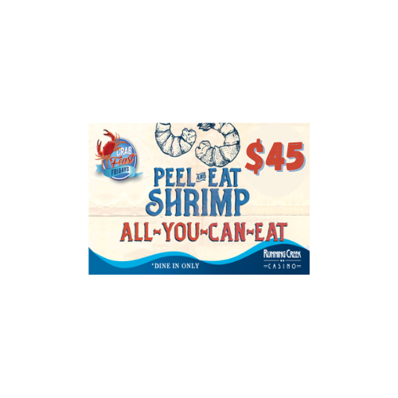

*Table will be charged for an additional order if sharing.*

Add Steamed Crab to any dish

at Market Price.

**Land & Sea**

*These items served with soup or salad.*

**Bacon Wrapped Filet**

Angus bacon wrapped filet served with garlic mashed potatoes, asparagus and blue cheese bacon chive compound butter. **42**

**Grilled Salmon**

Atlantic salmon filet topped with wasabi ginger compound butter, served with wild rice pilaf

And asparagus. **32**

**Chicken Teriyaki**

Airline chicken breast, broiled, served with pineapple bites, rice, and seasonal vegetables. Topped with teriyaki glaze. 28

**Pasta Dishes**

**Steakhouse Pasta**

Pappardelle, 8 oz. New York, mushroom garlic cognac cream sauce, served with garlic bread. **28**

**Crab & Shrimp Linguine**

Crab and shrimp in a sherry dill cream sauce with linguine noodles. **22**

**Wild Creek Favorites**

**Fish & Chips**

Beer battered Pacific Snapper with French fries, tartar sauce and

fresh-cut lemons. **19**

**Wild Creek Cheeseburger**

Seasoned brisket and sirloin patty (1/3 lb.) with cheese, house burger sauce, lettuce, tomatoes and onions on an oil-top bun, served with French fries. **19**

*(Vegan option available, add 3)*

**Wild Creek French Dip**

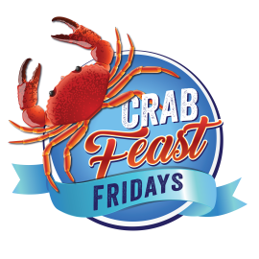Thinly sliced Prime Rib, sautéed onions and mushrooms served on a toasted roll with a roasted garlic aioli and served with au-jus and French fries. **19**

Due to supply issues beyond our control, we are experiencing shortages in product delivery and accessibility at this time. As a result, we may need to substitute or limit menu item availability. *Thank you for your understanding.*

.

Please inform your server of any food allergies or restrictions.

Corkage fee 10. Parties of 8 or more will add 15% service charge

**Beverages**

*Includes refills unless otherwise indicated.*

Pepsi/Diet Pepsi **2.50**

Dr. Pepper/Root Beer **2.50**

Lemonade/Iced Tea **2.50**

Hot Coffee/Hot Tea **2.50**

**Desserts**

Raspberry Cheesecake **9**

Crème Brûlée Cheesecake **9**

5 Layer Chocolate Cake **9**

Carrot Cake  **9**

Mudd Pie  **9**

**Ice Cream**

Chocolate Ice Cream  **4**

Vanilla Ice Cream  **4**

Consuming raw or undercooked meats, poultry, seafood, shellfish, or eggs may increase your risk of foodborne illness

Management reserves all rights.